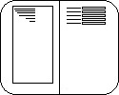GenKFI Users Guide

Jason Browne  
TRD IT

Written: 2013-12-02

Revised: 2013-12-02

Formatting Conventions

**BOLD CAPS** = KEYBOARD KEY

*Italics* = Webpage Button

Contents

System Requirements 2

Users 2

General Use 2

Repeated pages 3

Repeated Line Items 3

Managers/Supervisors 4

General Use 4

Batch Operations 4

Open Batches 4

Closed Batches 5

Viewing a Batch 5

Assigning Batches 5

Reassigning Batches 6

User Operations 6

Manage Users 6

User Statistics 6

Administrators/Maintenance 7

System Operations 7

Auto-Calculation Functions 7

Form Templates 8

Developers 12

System Operations 12

View App Errors 12

More Info 12

# System Requirements

* Internet connection
* Internet Browser
  + Internet Explorer 8 or higher
  + Google Chrome
* Monitor Resolution of 1920x1080 or higher
* Access to http://trdpipelinedev/GenKFI

# Users

## General Use

When first logging onto the system, your username will be added to the user list. However, since you are a new user at this point, you will have no batches assigned to you. If this is your first time using GenKFI, please speak to your supervisor so they can assign batches. This is also the screen you will see if you have keyed all your assigned batches.

Once you have batches assigned, refresh your browser and the first assigned batch will be loaded. You will be presented with the scanned image on the left side of the window. On the right side you will see a list of text boxes and check boxes on the right hand side. The boxes on the right will also have labels, corresponding to the label of the box on the image. The first text box on the left will be automatically selected, and you can begin entering data. When you are finished with one box, you may press **ENTER** or **TAB** to move to the next box. For checkboxes, simply pressing **SPACE** will check the box and move to the next box. All dates should be entered in the format MMDDYY. If needed, click in the white box in the upper right to display a calendar control. This can be used to check a certain date (i.e. if a certain month has 30 or 31 days). It will not put the date in any control. It is only there for reference.

When you have reached the end of the page/block, pressing enter on the last box will select the *Submit* button at the top of the page. Press **ENTER** once more to submit the data, and you will be taken to the next page in the return, or the next return/batch as appropriate.

You’ll notice on the scanned image, there is a light orange box. This box, or marker, is meant to move to the box on the image that corresponds to the box on the right hand side where the data should be entered. This is to help ensure the data is entered in the correct place. In the case that the marker might obscure data beneath it, the marker is slightly transparent to allow visibility. The marker, image, and entry controls will all be automatically aligned to provide visibility to enter the data.

It can happen that a scanned return does not line up correctly, and the marker position may be incorrect. You may click on the arrow buttons in the upper left corner to reposition the page below the marker, to realign the marker to the correct box. This offset will be kept until the next page. Since each scan is a different page, the offset is not kept between pages.

Other buttons in the upper left include: a rotation button, allowing you to rotate the image; zoom buttons (“**+**” and “**-**“), allowing you to enlarge or shrink the image to assist in readability; a R*eset Transform* button to undo all offsets and zooms, restoring the image to its original state.



To the right of the transform buttons, information about the batch and tax form is listed. If anything goes wrong, this information will assist in the resolution of the problem.

Near the center of the top bar is the *Submit* button, which will submit any data entered and move to the next page/return/batch. The *Home* button can be used to refresh the current page. This refresh will clear any data entered during this session, and reload any data previously submitted.

The *Form* button can be used to move to a different page within the current return. This should only be used to go to previously submitted pages and double check data. When clicked, a list of pages and forms for the current return will be displayed, with the current page highlighted. To go to a different page, simply click that row. *Again, this should only be used to go back, never forward in the return, to prevent possibly skipping a page in the return*.

### Repeated pages

Some tax programs may have pages that can be repeated as needed. These pages will automatically be retrieved and displayed for data entry. They will function as general pages, as described above.

### Repeated Line Items

Some returns may have line items with an unknown number of items to enter (such as PIT dependents listings). On these pages, you will be show the normal entry controls, as above, as well as an extra button below the entry boxes. When the first line item has been entered, pressing **ENTER** will select the *More* button. If there are more line items to enter, press **SPACE** or **ENTER**. The line item just entered will be submitted, and the page will display a second listing of entry boxes. The marker will be moved to the next line item, and entry can continue. Note again here that because of the variability in scanning physical pages, the marker may not be perfectly aligned. Continue this process until all items have been entered. When the final line item has been entered, press **TAB** on the *More* button to select the *Submit* button and submit the final line item. If you press the *More* button by mistake, simply **TAB** through the controls to get to the *Submit* button, or click on it directly. The empty line item will not be saved.

# Managers/Supervisors

## General Use

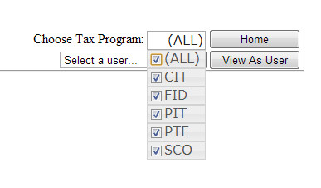Where general users are taken directly to their batches to key, Supervisors and Administrators are presented with a list of links to perform various tasks within the system. The first thing to notice is in the upper right hand corner. There you will find a label “Chose Tax Program:” along with a list of all tax programs in the system. This list will determine what will be shown on the following pages. By default, all tax programs are selected. If you wish to view statistics and batches for a single tax program or a small group of tax programs, you can use this list to select which tax program(s) you wish to view. This list of tax programs is on all pages except the data entry page and the form edit pages, described later.

Next to the list of tax programs is also a *Home* button. This button will return you to this start screen. The *Home* button is on every page except the data entry page.

Below these two items is also an ‘impersonation’ feature. There is a drop down list of all users in the system, along with a button labeled *View As User*. By selecting a user in the drop down list, and clicking the button, you can view the system just as that user would see it, with the addition of a red bar at the bottom of the page to remind you that you are impersonating another user. There is a reset button on that red bar that will bring you back you your supervisory pages. Note, when impersonating a user, you will be taken into that users batches to key. This is important to keep in mind, as it will change the queue order for the user if they are in the system at the same time when you are impersonating them. This feature can be useful for debugging reasons and to try to duplicate system errors a user might be experiencing.

## Batch Operations

### Open Batches

Open batches are batches that are available to be assigned to users and keyed. They can be found via the “View Open Batches” link on the main page. Note the open batches displayed will only be for the selected tax programs in the list in the upper right. Along the top of the list is a summary, with the number of batches, the number of headers or returns, and the number of items keyed.

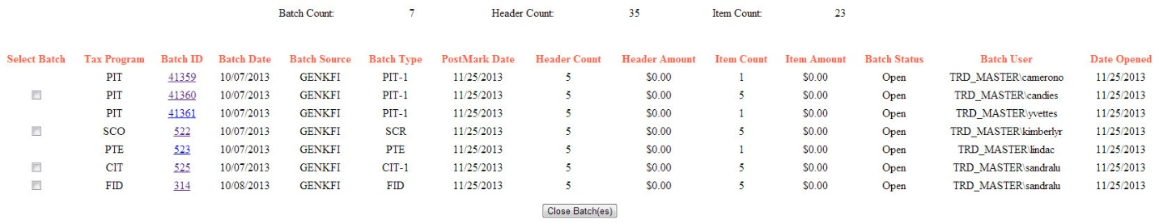

Open batches are listed in a table and includes information such as the date the batch was scanned, the postmark date, if keyed, and the user to which each batch is assigned. If a batch is fully keyed, a checkbox will be displayed on that row. A batch can be closed by checking that box and clicking the *Close Batch(es)* button below the table. This will mark the batches as closed and they will be picked up in the nightly job stream and be loaded into GenTax. Once they are loaded into GenTax, they will no longer be visible in GenKFI.

### Closed Batches

Once a batch is closed, it is listed on the Closed Batches page, accessible via the “View Closed Batches” link on the main page. This page shows the same information as the Open Batches page, but for closed batches. Similarly to the Open Batches page, each batch row has a checkbox which can be used to *Open Batch(es)*. The batches listed on this page are only accessible for one day, since the keyed data will be imported into GenTax that night. If a batch should not be loading into GenTax, be sure to reopen the batch before the nightly job stream runs.

### Viewing a Batch

On both the closed and open batch pages, each batch ID can be clicked on to go to the Batch Modify page. On this page several aspects of a specific batch can be edited. Each return in the batch can be viewed by clicking on the sequence number link on the left side of the table. This will take you to the data entry page, where the data can be entered or checked.

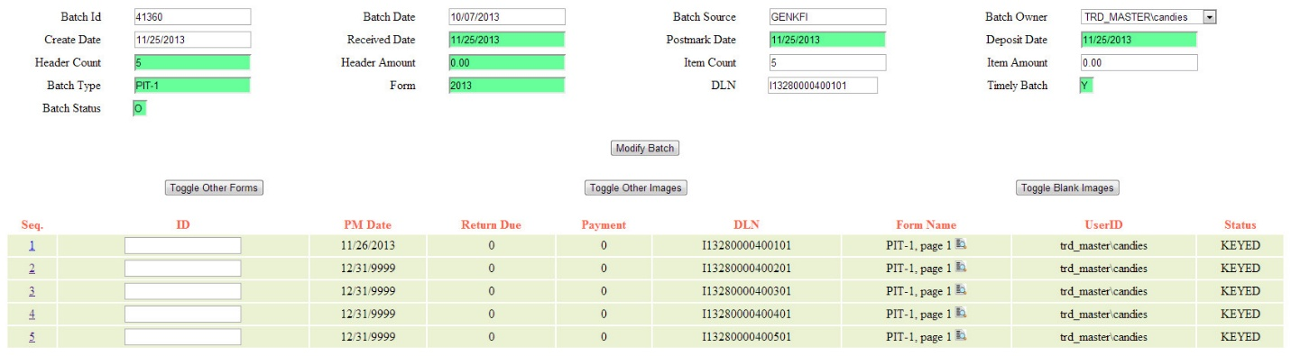

While allowing you to edit many properties of the batch, you can also (re)assign a particular batch to a user. This puts the batch in that users queue, and it will be shown to them as they proceed in their data entry. To assign a batch to a user, use the drop down list in the upper right of the batch information table, labeled “Batch Owner”, and click *Modify Batch*.

### Assigning Batches

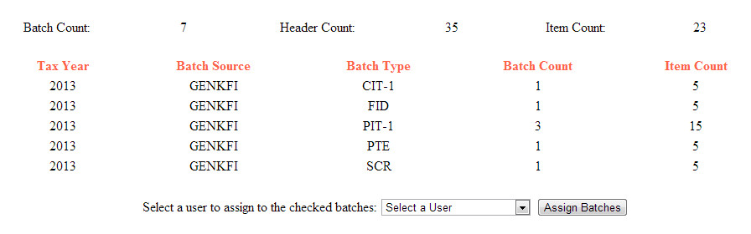Nightly, the system checks for new batches scanned the previous day. These batches are assigned to a special user named BATCH. Until these batches are assigned, they WILL NOT BE seen by any users. To assign new batches, use the Unassigned Batches page.

This page shows a summary of all batches and returns by tax program, as well as a list of the unassigned batches. Each batch listed has a checkbox. The checkbox at the top of the list will check all batches in the list. To assign batches, check the desired boxes, and select a user’s name in the drop down list. Click the *Assign Batches* button to assign the batches.

### Reassigning Batches

There can be times when a user’s entire batch queue needs to be reassigned, i.e. a user calls in or quits unexpectedly. In these times, that users batches can be reassigned individually using the above method. Alternatively, the Reassign Batches link can be used to reassign that users to another user.

Initially the page will not show any batches. At the top of the page are two drop down lists, each listing all users. At the top of each list are the admin and supervisor users. Then the special user BATCH is listed (this is the user for unassigned batches, described above). Then all normal users are listed.

Selecting a user in the top list will display all batches ASSIGNED TO that user, filtered by selected tax programs. The user selected in the bottom list is the user TO WHICH the batches will BE ASSIGNED. Pressing the *RE-Assign Batches* button will perform the reassignment, which will take effect immediately.

## User Operations

### Manage Users

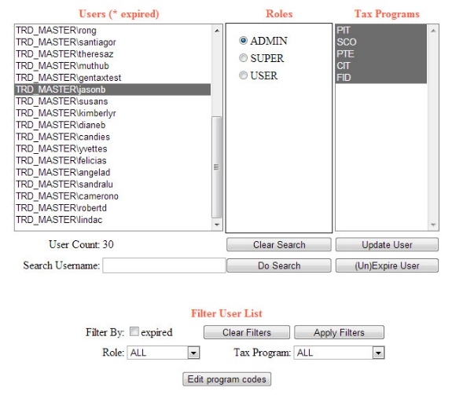On this page all users are listed, along with their roles and tax programs. The displayed list can be filtered by expired status, role, and/or tax program. If any changes are made to a user, be sure to click *Update User* to save the changes. A user can be “expired”, which will prevent the user from accessing the data entry pages, and display a notice to the user the next time they log on. Note this will not remove their assigned batches. Expired users can be un-expired at any time, and that user will again have access to their assigned batches.

### User Statistics

This page displays number of returns keyed. The statistics are broken down by date, tax program, and user, with appropriate summations and totals. Initially statistics for all users and selected tax programs are displayed. This can be filtered further by date and/or user. Clicking on a user’s name will filter the displayed statistics to that user. Note also that, as with other pages, the displayed information is filtered to the selected tax programs, listed in the title and in the drop down list in the upper right of the page.

# Administrators/Maintenance

## System Operations

### Auto-Calculation Functions

Many of the tax forms have boxes that require the tax payer to perform certain calculations. The digital entry form for these fields can also be automatically calculated. That functionality is provided by way of template functions. A template function is a function that can take values from any of the fields on a form, and perform desired calculations on those values. While many template functions can be strung together, in themselves template functions are quite simple JavaScript stamps.

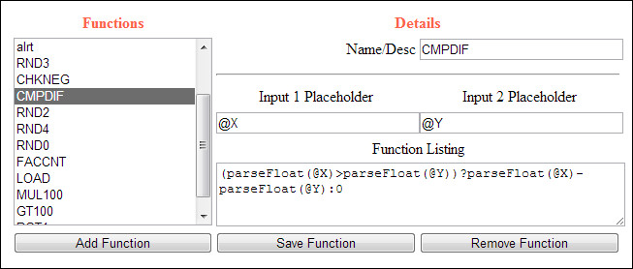

A template function always takes two inputs. These inputs are simply placeholder names. They will be replaced on the form with the values in appropriate fields. When building template functions, it is best practice to always prefix input names with ‘@’. This is to prevent mangling JavaScript function names when replacing the names with the desired values. For example, when the template uses the java script function `parseFloat(a)`, and the input name is `a` which should be replaced with 7, the resulting JavaScript would be `p7rseFlo7t(7)`, which clearly won’t work.

All template functions also have a name, for ease in reference and readability.

#### Example

To define an integer summation function, name the two input parameters `@X` and `@Y`, and enter the following in the template function listing:

parseFloat(@X) + parseFloat(@Y)

#### Usage

When building template forms, there is an option to enter auto-calculation functions for a field. Simply select the function you wish to use, and set the input fields to use, corresponding to the input parameters.

Template functions can be strung together, to provide, for example, the sum of more than two previous fields. When building the template form, add the first function as normal. Then add another auto-complete function, and instead of setting an input field name as an input, select `Previous Row`. This will place the result of the previous function into the input parameter of the second function. Likewise, constant values can also be used as one of the inputs. This is discussed in more detail in the section about Template Form Building

### Form Templates

Given the variability of tax forms from year to year, GenKFI has the capability to reflect those changes with minimal effort. From the main page, select one tax program from the drop down list in the upper right. Since each tax program has their own specific forms, to proceed, only one tax program can be selected. Then click on the “Manage Form Templates” link at the bottom of the page.

#### By Year

This page displays the forms for the selected tax program, grouped by tax year. On this screen there are three options. Forms for a tax year can be removed, which will delete all headers, forms, and controls for the selected tax program and tax year. Also, forms can be copied. This option makes a copy of all of that tax year’s forms and controls, and take you to the Block and Batch page. Or you can simply click on “Edit Form” to go to the Block and Batch page for that tax year.

If this is the first tax year being entered for this tax program, select a year at the bottom of the page and enter a file type name, typically the tax program abbreviation followed by the two digit year, i.e. ‘FIDR12’.

#### Block and Batch

If you are making a copy of a particular tax year, be sure to update the tax year at the top of the page, as well as the file type, if applicable, and click *Save Header Values*.

When starting a new tax year, be sure to verify that the displayed tax year and file type name are correct.

On this page are defined two types of objects, Tables and Blocks. The first, tables, are the base of any form or block. The table is the place in the database that will hold the keyed data. To add a table, enter the appropriate information at the bottom of the page and click the *New Tax Form* button.

After adding a table, you’ll notice that the new table is listed as having a block number of zero. This means we have a base to build our form or blocks from. To the right of the newly added table is an Add Block link, and a Remove All Blocks link. The Remove All Blocks link will remove all blocks under that table. If there are no blocks, it will remove the table itself. Note, this will not actually remove the database table, just the reference to it. No keyed data will be lost by removing the table header.

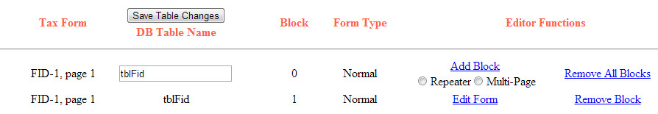

Blocks are logical portions of a tax form. Some tax forms are simple enough to only need one block. Others have different forms of data (such as name and address and income information on the same page) which can be split into different blocks on the same tax form. Thus you can add multiple blocks to one table header. Every table header needs at least one block.

Blocks can also be designated as Repeater or Multi-Page. A Repeater block is a table-like structure, with multiple lines of the same types of information, such as a list of dependents. The Repeater block will gather data, moving down the page as it does. A Multi-Page block is an entire page that can possibly be repeated. In this case, instead of repeating on one page, the entire page form is built, and the scanner designates if there are more pages of the same type to load and collect data from.

This page automatically checks the database structure to ensure all the blocks will work as intended, and needed data is able to be saved. If there are any problems with the required database tables and/or columns, the tax form name listed on the left will be flagged with a red asterisk, letting you know there is an issue to resolve before that form or block can be used.

#### Form Building

Before building a digital form, you will need the path to a template scan. Enter the path and file name of the template scan in the ‘Path’ box at the top of the page and click *Load/Save Template*. This will load the template scan in the browser and associate the file with the block. If there are many controls, they may be rendered below the option tabs. Use the ‘Show Controls’ link in the upper right to hide the options tabs and view the controls.

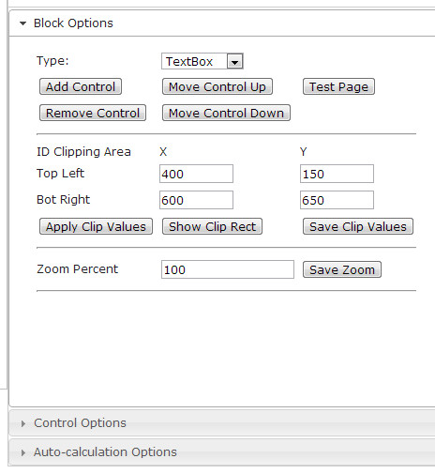Use the ‘Block Options’ tab on the right side to add, remove, and order the controls that will be used for data entry. New controls can be either text boxes or check boxes. Control options are edited on the next tab, described below. This tab is also used for some template image formatting. The zoom value can be edited and saved, as well as the ID clipping area. The zoom value is updated when the zoom buttons in the upper left are used. Remember to click *Save Zoom* when changing the zoom value. This zoom value will be applied to this block on every return.

The ID clipping area is used on the Batch Modify page, to display the area of the scan with the appropriate ID for each batch. Clicking *Show Clip Rect* will show the ID clipping area, which can be dragged and resized. Alternatively, the values can be entered directly and applied to the displayed clipping area. When done, click *Save Clip Values*. This tab also provides a button to test the page, which can be used to test the display and auto-calculation fields of the block.

When there are controls, they will be displayed on the right hand side, very similar to how they will be displayed for data entry. The controls have radio buttons to their left for selection, or for text boxes you can simply select the box. When a control is selected, the ‘Control Options’ tab updates with that control’s settings, described below. When controls are selected, the image and marker can be moved to make the data or scan easier to see, as well as indicate what data should be entered in the control. This is controlled by the ‘Image Scrolling’, ‘Marker Position’ and ‘Control Scroll Position’. These values can be entered by hand, or by simply dragging the marker and image to the desired location. When updated, click *Save Options* to save the values in the system.

* + 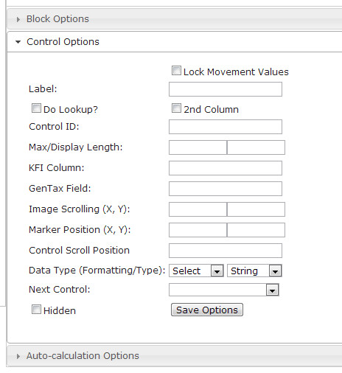**Label**: This is the label displayed next to the control.
  + **2nd Column**: Controls are automatically rendered on separate rows. This selection causes the selected control to be rendered on the same row as the previous control.
  + **Control ID**: This is the name of the control behind the scenes, used to populate the form with data that has already been entered, if any.
  + **Max/Display Length**: These values limit the number of characters the user can enter in a text box. These are unused for check boxes.
  + **KFI Column**: This is the column in the database where entered data will be saved.
  + **GenTax Column**: When the nightly extract runs, this is the column where the entered data will be saved in GenTax.
  + **Image Scrolling (X, Y)**: When the image is dragged, these values are automatically updated. They can also be updated by hand and saved to keep the image aligned between controls.
  + **Marker Position (X, Y)**: When the marker is dragged, these values are automatically updated. They can also be updated by hand and saved to keep the marker aligned between controls.
  + **Control Scroll Position**: When there are more controls that can fit on the screen, this value will automatically scroll the window. This is used to keep active controls in view. This value is automatically updated when the window is scrolled.
  + **Next Control**: When the user presses **TAB** or **ENTER** on a form, the system will automatically move focus to the next control. This drop down lists all controls on the form, and indicates which control the system should move focus to. On the final control of the form, be sure to set ‘Finish Form’ as the next control. This will be sure to auto-select the *Submit* button on a form when the user is finished keying.
  + **Hidden**: When GenTax needs information that is not required on the form, a control can be made hidden, thus making it a dummy control that is not used. It will not be shown to the user. Hidden controls are indicated by asterisks around the label in the controls list on this page.
  + **Data Type**: The first of these two drop downs lists the possible formats of data in a text box. When a text box loses focus, the selected formatting will be applied. This can make the data more human readable, or be used to filter and format values before saving them in the database. The second drop down lists four data types, which is the data type used for the database column.

Not listed in the above list is the ‘Do Lookup?’ checkbox. When a control has the data type FEIN, CRS or SSN, this box will be available. When checked, it will direct the system to use the ID entered by the user to find the tax payers information, such as name and address, and automatically fill in the appropriate controls. This is meant to save the user some time in entering the data.

Also not listed above is the ‘Lock Movement Values’ checkbox. When aligning the image and marker, selecting a new control will move the image and marker to the values stored for that control, by default (0, 0). Checking this box will freeze the image and marker at the current values when selecting a new control. This allows for easier alignment while building the block, instead of having to reset the image and marker movement values from the defaults for each control.

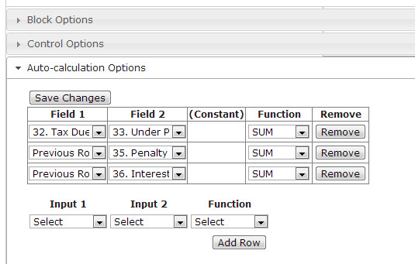The last tab, ‘Auto-Calculation Options’, is used to set JavaScript template functions mentioned earlier. If any updates have been made to the controls (labels, number of controls), you will have to reload this page to update the drop down lists here. Select the template function you wish to use in the rightmost drop down list. Depending on the template function you wish to use, select the appropriate items in the first two lists and click *Add Row*.

In the first two lists, all the controls for this block are listed, as well as ‘Constant’ and ‘Previous Row’. ‘Constant’ can be used when a function only required one control value to operate, such as dividing a percent by 100. ‘Previous Row’ is used when multiple template functions need to be strung together. This will take the output of the template function on the row above, and use that as the selected input to the current template function. In the image below, the values of several controls needed to be summed. In the first row, two controls are used as the inputs. In the second row, the value of a third control is added to the sum of the first two controls from the previous row. Notice that changes to the inputs, functions, and constants can be made directly on the row. If any changes are made to the rows, *Save Changes* must be click to ensure the changes are saved in the database.

When all controls have been added and all image and marker movements have been defined, click *Done* at the top of the page. The system will check the database for the table and columns needed to hold the data that will be entered through this form. If the table doesn’t exist, or a column is missing in the table, the next page will generate the SQL statements needed to ensure the form will work as intended. Bring these SQL statements to a DBA to update the database before users begin to key returns for this tax program/form. If the database is already up to date, you will be taken back to the Block and Batch page.

# Developers

## System Operations

### View App Errors

This page displays any system errors that might have occurred. It is simply a display of the table errMsg. It lists the error message, the user session that caused the error, and the call stack info. It can be used to quickly check on the health of the system. When fixing any errors, update the table in the database with the performed fix.

## More Info

Please reference the GenKFI Developers Guide for more details.